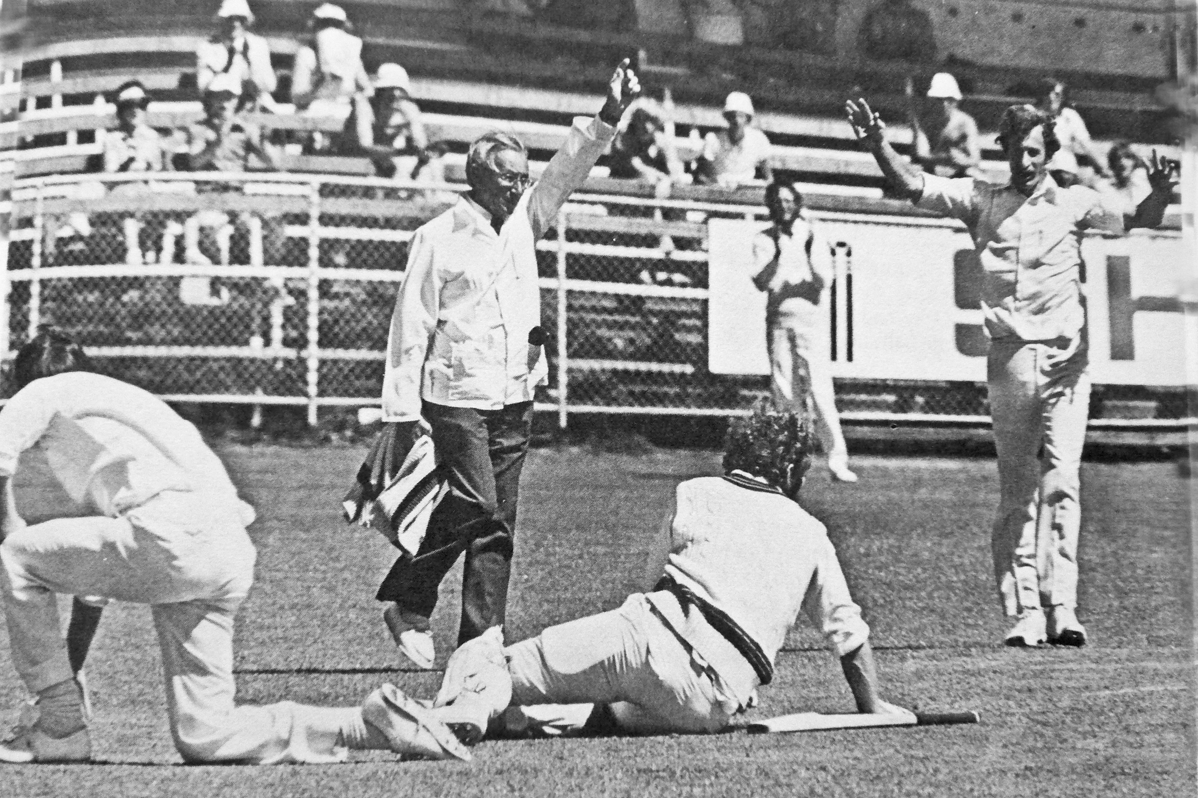

**Lance Cairns is run out for 11. Dayle Hadlee and Warren Eddington celebrate. Umpire Frank Fielding**

**13 January 1978 Lancaster Park.**

**Otago 253/7 declared and 145 Canterbury 200/7 declared and 202/8. Canterbury won by two wickets**

.